**STANDARD OPERATING PROCEDURE**

**for**

**FLUME VEGETATION EXPERIMENTS**

**1.0 INTRODUCTION**

Sediment in aquatic systems can act as a vector for contaminant transport or as an aid to landform development in aquatic systems. Biofilms - organic material which forms on the surfaces of aquatic vegetation - are hypothesized to affect sediment transport in vegetation canopies (CAREER Proposal).

**2.0 METHOD SUMMARY**

This SOP details the setup and procedures specific to experiments conducted in the Ecogeomorphology Flume in McCone Hall, UC Berkeley. Refer to instrument-specific SOPs and manufacturer operating manuals for further details on the operation of the Ecogeomorphology Flume, LISST, Vectrino, and all other software and hardware.

**3.0 EQUIPMENT AND SUPPLIES**

3.1 Supplies for standard experiment

* Nortek Vectrino Velocimeter
* Sequoia Scientific LISST
* Laptop(s) with LISST and Vectrino software installed (currently using Panasonic Toughbook)
* Peristaltic pumps (2)
  + and at least two lead-acid batteries to power them (good to have some extras on hand)
  + Battery charger
  + 6 [tubes](https://www.coleparmer.com/i/masterflex-norprene-food-tubing-a60-f-l-s-16-50-ft/0640216) (Masterflex, A60 “food grade”)
  + 6 pump heads
* Aluminum rods, at least 30” length, approximately ¼” diameter (other non corrosive metal good too, or potentially plastic or wood)
* Zipties
* 125-mL and 250mL Nagene sample containers (quantity depends on number of peristaltic pump samples to be taken)
* Masking tape and sharpie/pen
* Ruler with cm
* Notebook or [data sheet](https://docs.google.com/spreadsheets/d/1xXCBpdyqeuDZvr-jMS58HLGSgH60thfbLmej39HTY84/edit?usp=sharing)
* 8020 beams and connectors for Vectrino
* Hex/allen keys
* Rope to fix LISST in place (at least 20 feet)
* Flume with [vegetation array](https://drive.google.com/open?id=1Kz7r6apvE45iflfMu09BJ_RONY3LuPipBL1tknP4r9k) installed
* Step Ladder
* DTAF tracer (see separate SOP in lab)
* Sediment, such as:
  + [Walnut Shell Flour](https://compomat.com/walnut-shell-blast-media/)
  + Silt, e.g. from Berkeley Aquatic Park, or something like [this](https://www.wardsci.com/store/product/8887946/soil-sands-and-gravel-set)
  + Floc, field-collected sediment, or similar (experiment-specific)
    - Kyle Strom’s Floc Recipe:

“For kaolinite only we use:  
- 50 mg/L Kaolinite   
- ≈ 10 g/L NaCl (10 ppt) (you don't have to be real accurate on the salt amount… anything over 5ppt seems to do the trick)  
- No Alum  
For really nice big fluffy flocs, we use 80% kaolinite and 20% montmorillonite at the desired concentration. You will get nice big flocs without salt with the added montmorillonite.”

***Tips for making floc in the flume:*** When the flume filled to 45cm depth, total volume = 822 gal. Use 15.5 kg NaCl (5 ppt, use the bags of salt in the lab for this purpose) and 155g kaolinite. To prepare, drain about 50 gallons out of the flume (you’ll add the the volume back via concentrated floc in the next steps). In a 5 gallon bucket, prepare brine. Mix ~1.5 kg NaCl with ~2.5 gallons tap water until NaCl is fully dissolved, then pour the solution into the test section of the flume. Repeat until all the salt is dissolved. Run flume on 10 hz during this process to ensure that salt is well-mixed throughout the flume. Dilute the kaolinite in roughly 2.5 gallons of tap water and mix well; add this mixture to the flume only after all sensors have been set up, flume is running, and data collection has begun so that the sensors can collect some baseline data for 5-10 min before addition of kaolinite induces particle flocculation.

For the addition of any sediment, it has been observed that if the sediment is added in a brief pulse all at once, this causes a periodic trend in volume and mass concentration over time. Thus, the solution is to add the sediment slowly over the length of time it takes for water to circulate once through the flume (about 3 minutes at 30Hz). Visually, this is when the first visible sediment comes back around to the point where it was initially added.

3.2 Supplies for construction of vegetation array (see [additional notes](https://docs.google.com/document/d/1Kz7r6apvE45iflfMu09BJ_RONY3LuPipBL1tknP4r9k/edit?usp=sharing))

* Wooden dowels (⅛” diameter, variable quantity, 24” minimum length)
* Two sheets of 23.5” by 78” by 3/16” perforated PVC sheet with 3/16” holes [[link](https://www.mcmaster.com/" \l "92985t57)]
* 1 sheet of 23.5” by 78” by 1/4” PVC sheet (non-perforated) (TAP Plastics)
* Cordless drill
* Drill bits
* Hole saw drill bit
* Hex nuts (316 Stainless Steel, 8-32 thread size) [[link](https://www.mcmaster.com/" \l "90257A009)]
* Flat washers (316 Stainless, Steel, No. 8 screw size, inner diameter: 0.174”, outer diameter: 0.375”) [[link](https://www.mcmaster.com/" \l "90107a010/=1buwde)]
* Lock washers (316 Stainless Steel, No. 8 screw size, inner diameter: 0.174”, outer diameter: 0.293”) [[link](https://www.mcmaster.com/" \l "92147a425/=1buwqup)]
* Threaded rods (316 Stainless Steel, 8-32 thread size, 12” length) [[link](https://www.mcmaster.com/" \l "93250a052/=1buwcsx)]
* Eyebolts (316 Stainless Steel, 10-24 thread size, 1” shank length) [[link](https://www.mcmaster.com/" \l "9489t514/=1buwwo1)]
* Crescent wrench
* 50 mL plastic syringes (for use as sediment traps)

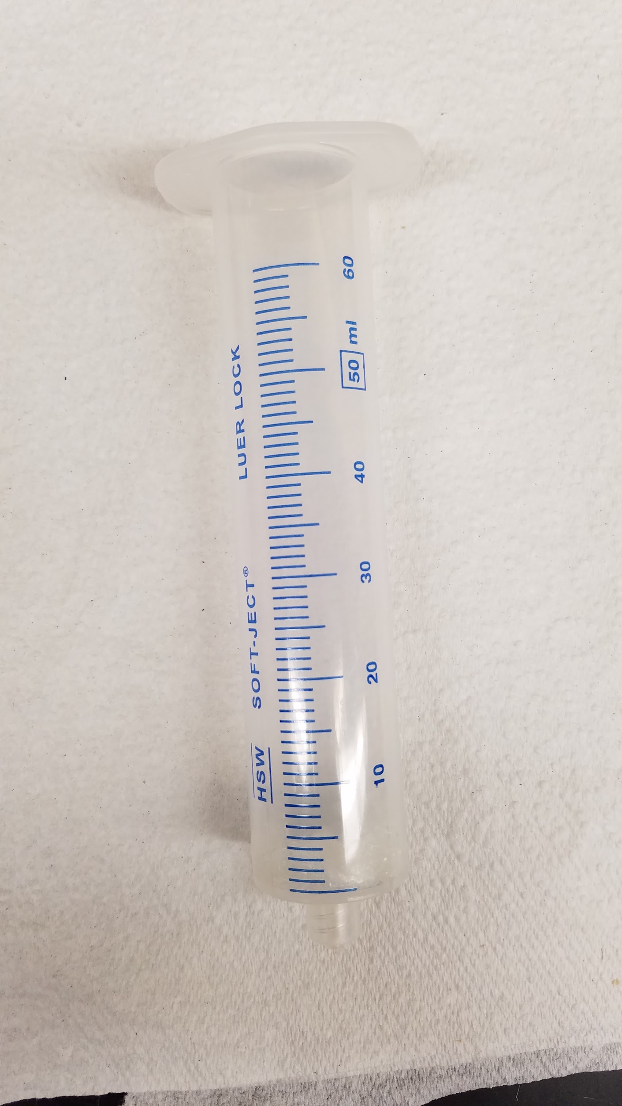

* Gorilla glue, Weld-It, or similar (for plugging syringe holes)
* 50 mL falcon tubes, filled with water (or something heavier, preferably) and styrofoam holders (to support lower section of PVC sheet against bowing)
* Wall putty, oil-based clay, or similar (acts as weight against the buoyancy of wooden dowels)
* Peristaltic pumps, 12V lead-acid batteries, pump tubing, sample containers (e.g. 125mL nalgenes)
* 8020 building materials to build a support structure for the Vectrino, and potentially as scaffolding for positioning the peristaltic pump tubes in the test section
* 2 Thin metal rods, at least 2 feet long or longer, to position the peristaltic pump tubes.
* Potentially a clamp, for attaching peristaltic pump tube rod

Note: All metal components used in construction of the vegetation array should be 316 stainless steel grade (“Marine grade stainless”) to prevent corrosion while in contact with water in the flume, especially in saline setups. The original setup used a lower grade, resulting in extensive oxidation of metal parts (see below).

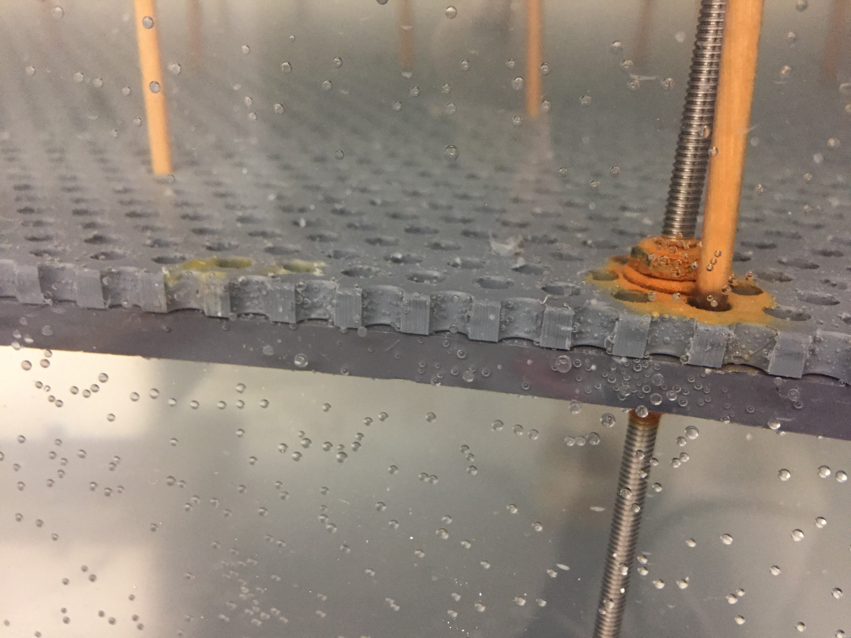

3.3 Material Preparation (skip sections as necessary)

3.3.1 Sediment Traps

1. Seal the bottoms of 50 mL plastic syringes using Gorilla Glue/Weld-It/preferred sealant to create sediment traps (9 currently)
2. Cut off the front half of the lip on the opening of the syringe with a hacksaw so that there is no leading edge of plastic when the sediment trap is inserted into its hole in the test section. This is intended to prevent boundary layer effects that could prevent sediment from entering the traps.
3. Label each syringe/sediment trap with a letter (e.g. A, B, C, ... ) for records
4. Drill holes for sediment trap positions in the perforated sheet at desired locations using the cordless drill and hole saw (9 holes in current setup)
   1. Save the drilled-out hole for sediment trap covers
5. Paste flat washers on the edges in the drilled-out perforated sheet “circles” to create sediment trap covers (see image below)

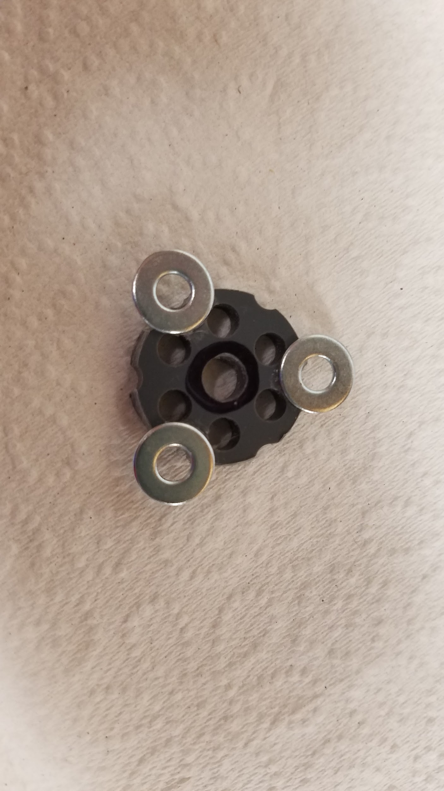

3.3.2 Perforated Sheets

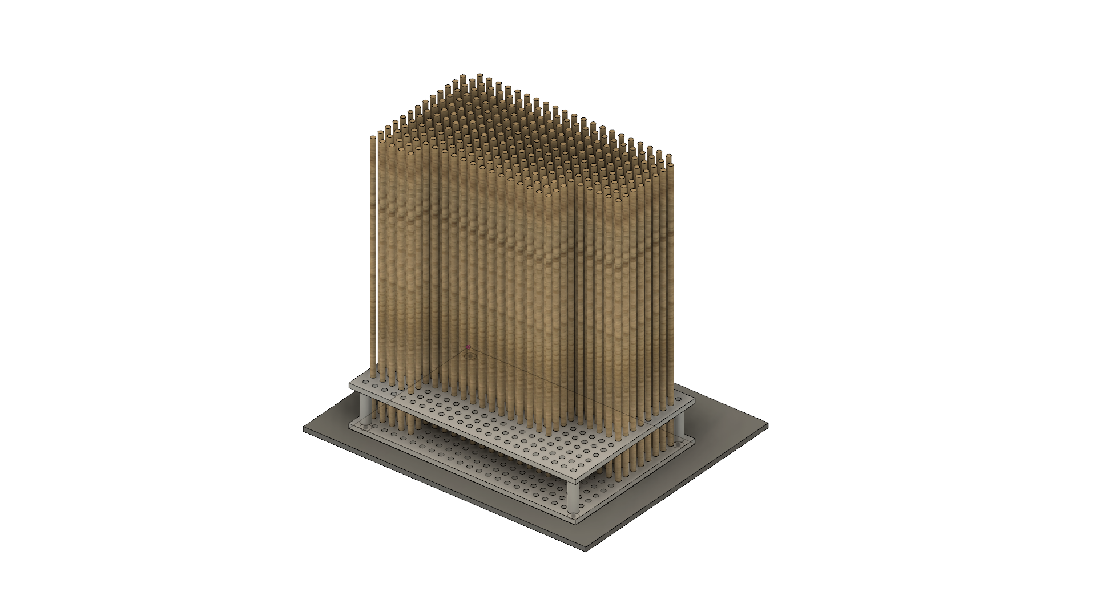

1. Paste hex nuts on the bottom side of one perforated sheet to support eye bolts that will be used to lift the sheet using the crane; this perforated sheet will be the upper sheet in the schematic shown above
   1. These positions should be located strategically to ensure the perforated sheet does not bend too much during lifting; we found that a “cross” formation lengthwise and widthwise worked reasonably well
2. Secure the remaining perforated sheet and the nonperforated sheet; these sheets together will be the bottom sheet in the schematic shown above
3. Drill holes through the perforated sheet into the nonperforated sheet to create holes for eyebolt support using the cordless drill
   1. Again, we found that a “cross” formation worked well
4. Drill holes through the perforated sheet into the nonperforated sheet to create holes for the threaded rod support along the margins (16 in the current configuration)
5. Screw eyebolts into the bottom sheet (perforated and nonperforated) using hex nuts and flat washers
   1. For the best support, the setup should be (from bottom to top), hex nut > washer > sheets > washer > hex nut going through the eyebolt
6. Place falcon tubes (filled with water or, preferably, some denser material) and stands at the bottom to the test section to support the bottom sheet from bowing
7. Lift the bottom sheet over the test section of the flume using the crane
   1. Use ropes/straps through the eyebolts
8. While the bottom sheet is suspended over the flume, attach the threaded rods around the margin
   1. From bottom to top, it should be hex nut > washer > sheets > washer > hex nut going through the threaded rod
   2. the length of the threaded rod extending from the bottom of the sheet should be equal for all locations to ensure the vegetation array is steady
9. Attach rubber “feet” to the ends of the threaded rods that will touch the flume bed
10. Lower the bottom sheet into the flume test section
11. Screw in hex nuts from the tops of the threaded rods to a height that will allow the top sheet to be flush with the flume bed upstream and downstream of the test section
12. Lift the upper sheet over and onto the bottom sheet (will be supported by hex nuts)
13. Secure the upper sheet to the threaded rods with a hex nut at each rod; the end result should resemble the image below

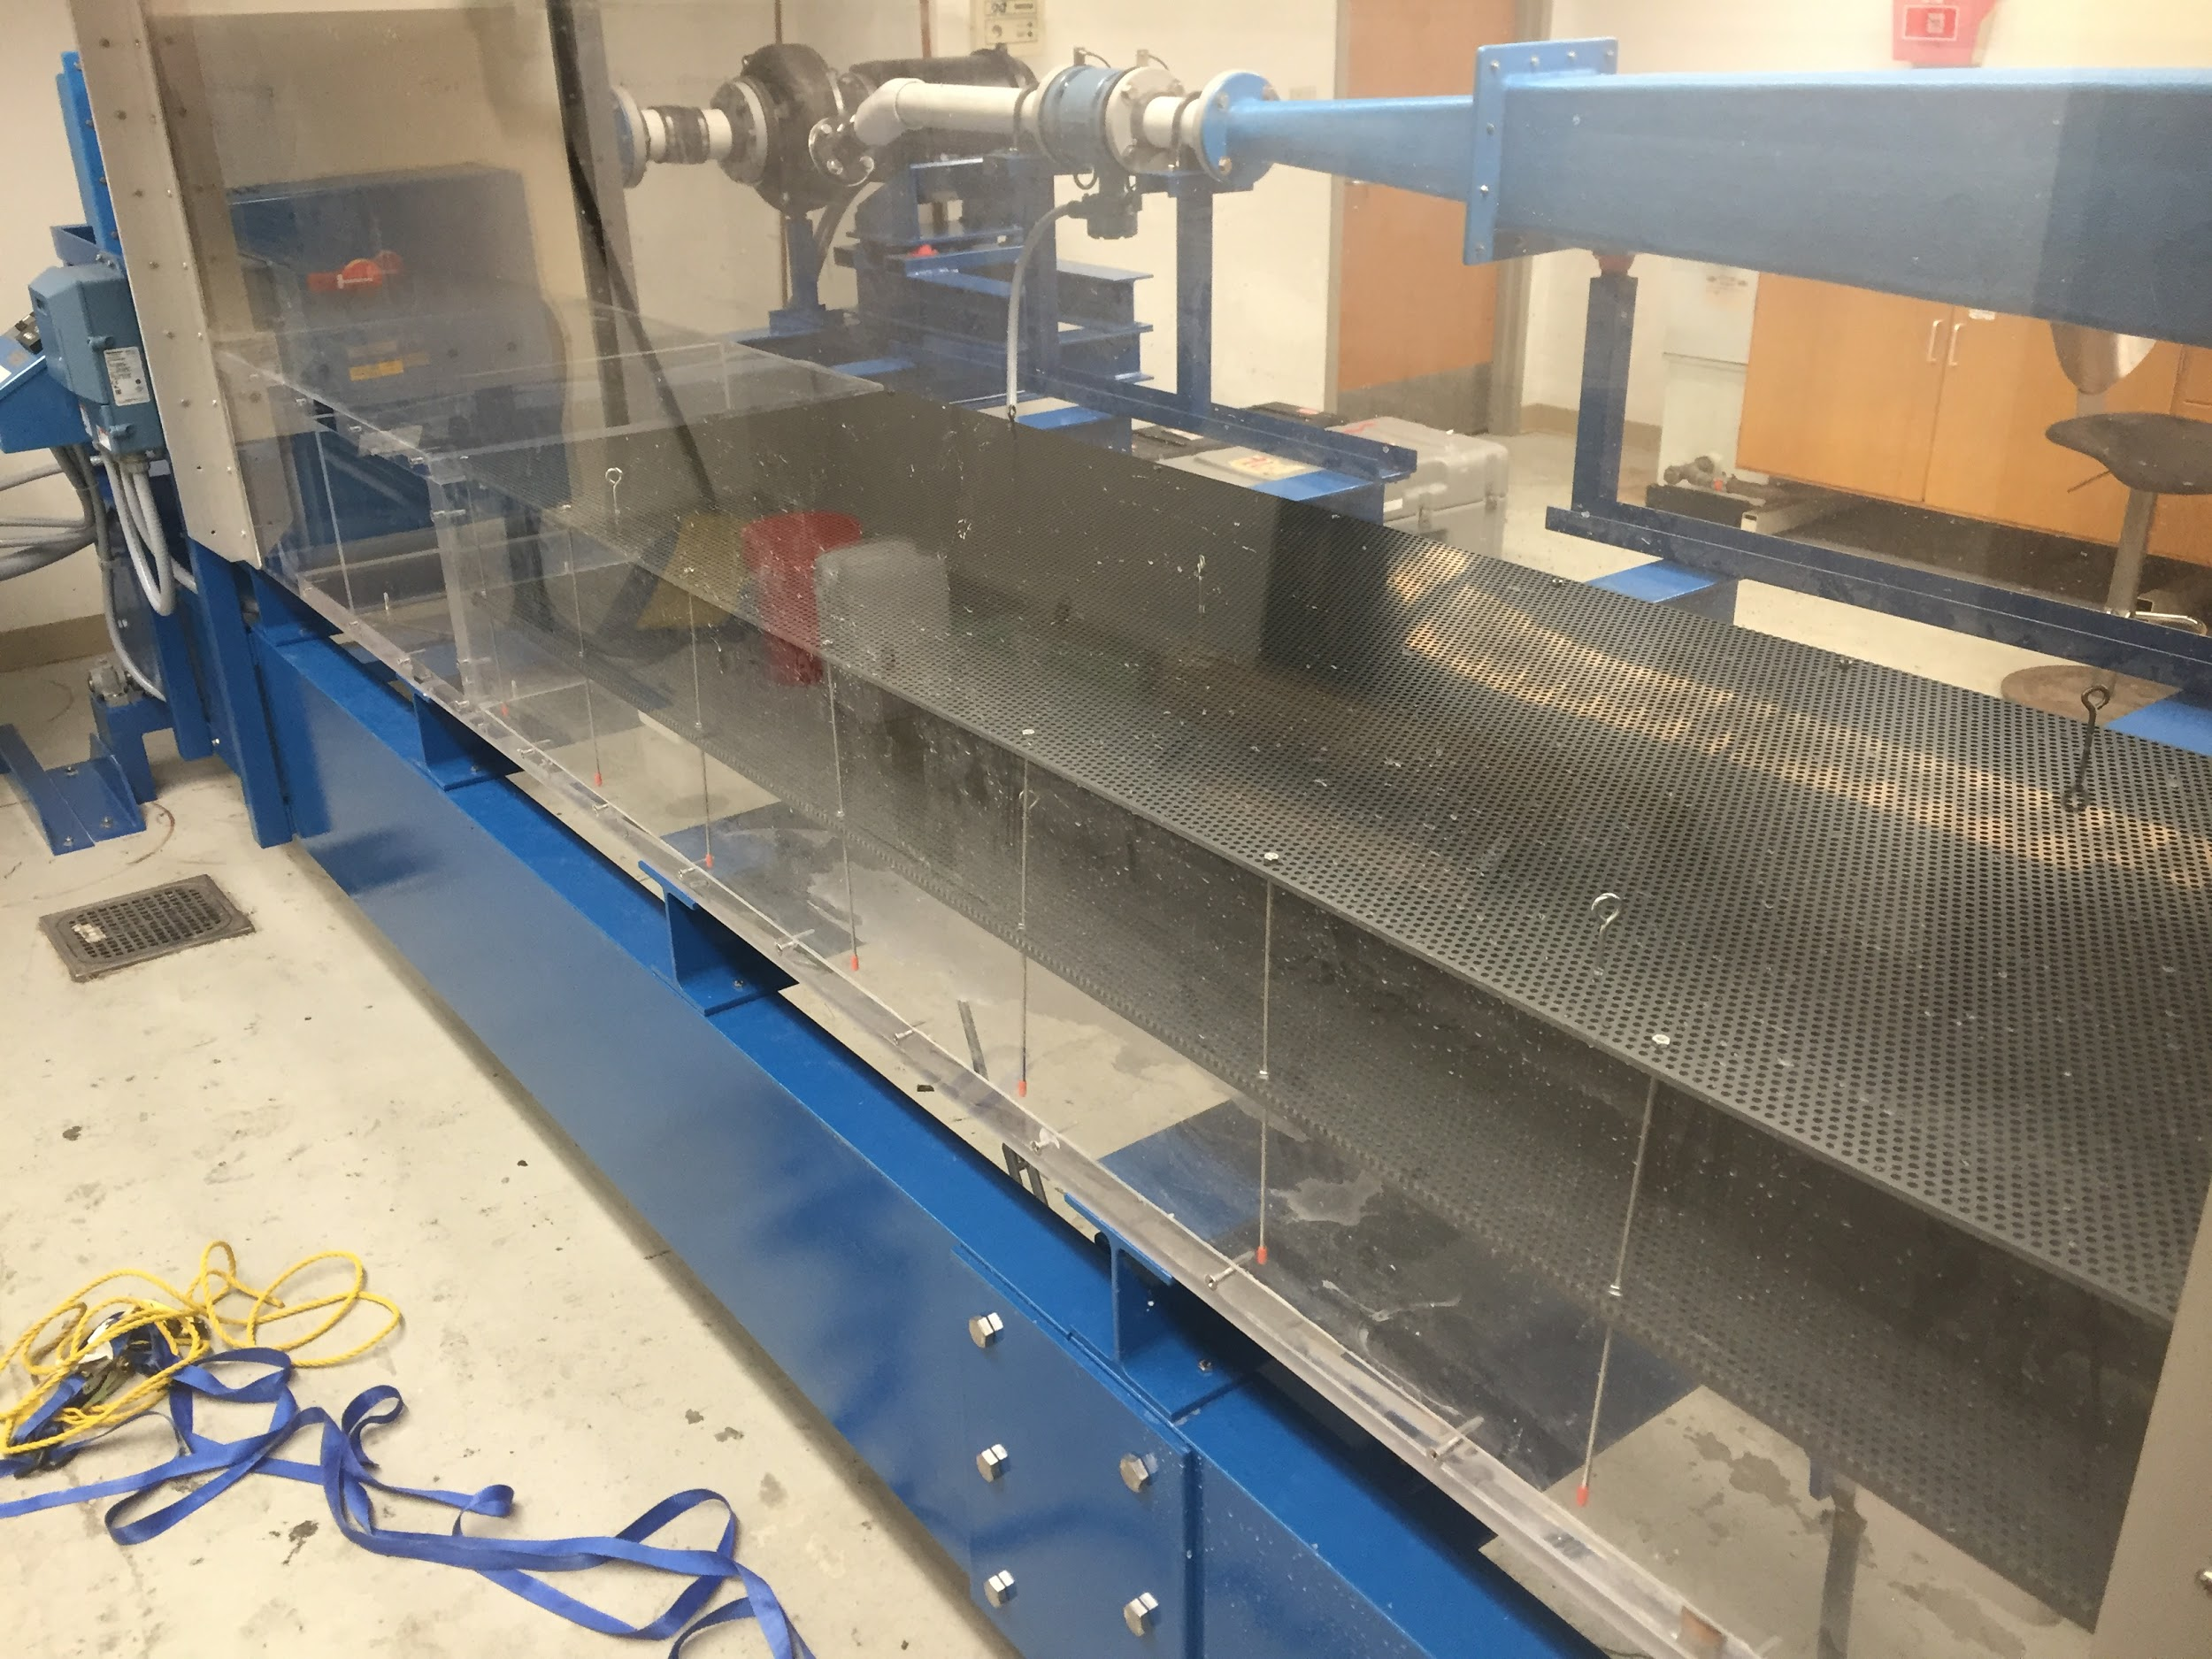

**4.0 LABORATORY PROCEDURES**

4.1 Standard Experiment Procedure

4.1.1 LISST Setup (see image below)

1. Connect LISST to battery and laptop computer using cables.
   1. Open LISST software and selection instrument -> connect
   2. If instrument does not connect, then try reconnecting on a different COM port (Communication > Serial Port Settings). Also try closing and reopening the LISST software.
   3. Once all the buttons along the top are colored rather than greyed out, you *might* be connected.
2. Collect a background scattering file (requires 2 people)
   1. Fill a clean 5-gallon bucket with tap water and allow it to sit covered overnight. The LISST laser alignment may be sensitive to temperature variations; thus, the water should be at room temperature. Air bubbles can also affect the background scattering value and ensuring their absence is another reason to let the water sit overnight.
   2. The following day (the day of the flume experiment) collect background scattering file. Ensure that the bucket of water remains free of all visible particles and bubbles and that there are no visible particles on the LISST (a quick rinse of the sensor end under the tap will help ensure this). With the LISST connected, click the icon with light blue bar graph to open the background scattering collection window. Use the default factory zscat file when the window prompts for it. Since a background scattering measurement takes only ~20 seconds to collect; in the past, several test collections have been performed until the scattering error value becomes relatively consistent, usually in the neighborhood of 10-20 ul/L. Note: the software will indicate that the test has failed if the error is above 0.3 ul/L. Though this is perhaps true, we’ve never achieved an error of below 0.3 and have only consistently been able to obtain values as low as 10-20.
   3. Disconnect cables from LISST for transporting it over to the test section of the flume.
3. Place LISST in flume (2 people preferred)
   1. Place the LISST battery in the overhead cart using the two plastic stands that come with the LISST
   2. Attach rope to slightly narrower middle section of the LISST with prusik hitch, timber hitch, or similar (see image below). The knot needs to be strong and tight enough to securely hold LISST in place vertically inside the flume. However, the LISST should sit on the bed surface and thus the rope is not weight-bearing, but rather for alignment and support.

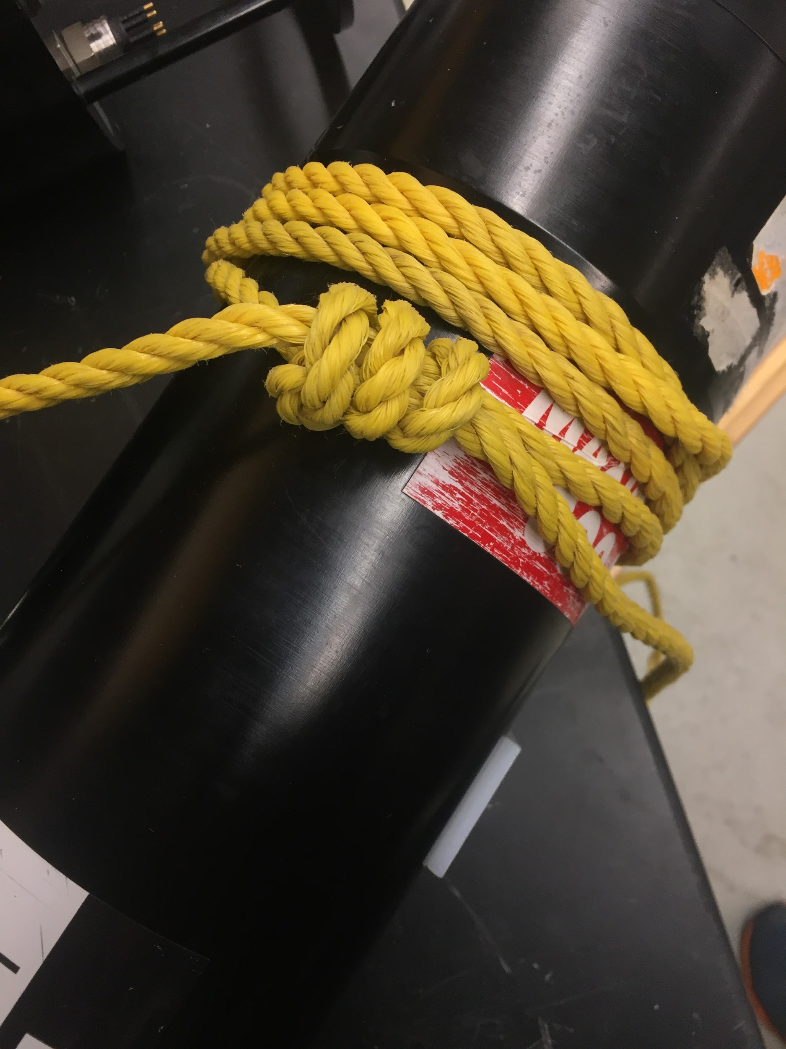

* 1. Place LISST vertically inside flume (~50 cm from downstream end of open section) with sensor end facing down. Attach the free end of the rope to the overhead metal fixture and make firm once LISST position is finalized.

Tips on LISST placement and operation:

* Orient the flat sides at the bottom end so that they’re parallel to the long direction of the flume to minimize drag and allow water to flow through the sensors.
* One person can look from upstream or downstream end of flume to ensure that LISST placement is centered and vertical while other person is tying the LISST in position
* LISST may be unable to collect data after sediment/floc is added due to high turbidity. May need to decrease concentration of sediment/floc.
* **Experiment to Determine Sediment Mass to add to Flume:** The solution to the previous point is to conduct a small-scale experiment in a 5-gallon bucket with the LISST in Realtime data collection mode. The Auxiliary Parameters window displays realtime transmission values. Add 3-4 gallons of water to the bucket; enough so the LISST is fully submerged. Make sure measure exactly how much volume is added for performing a mass concentration calculation. Attach one of the black propellor pumps to the bucket’s interior to circulate the water and prevent settling of the sediment as it’s added. From a known quantity of sediment (tare a plastic bag, add some sediment and record initial mass), slowly add small amounts of it to the water and monitor the transmission values recorded by the LISST. Depending on sediment type, clumps on the surface may need to be agitated with a pen or screwdriver tip in order to break them up. The ideal range of transmission values is between 0.55 and 0.75 (although the LISST is capable of collecting outside of that range). Once a transmission value in this range is achieved, end the experiment and calculate the mass concentration of sediment that was present in the bucket (mass sediment / volume of water). The result should be used as the starting concentration of sediment in the flume. Amount of sediment to add initially = mass concentration (determined in the bucket experiment) * volume of water in the flume.

LISST software setup (after background scatter is collected)

-calibrate clock

-sample is average of 10 measurements

-sample interval: 1s

-set start and end times

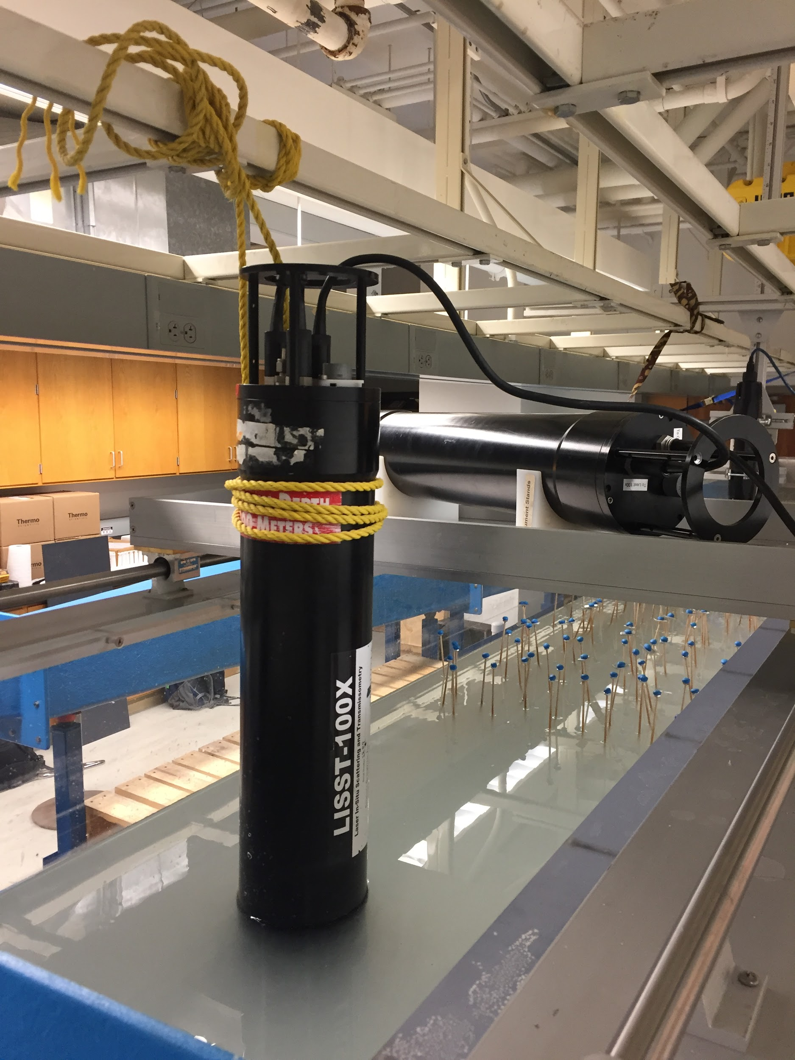

4.1.2 Vectrino Setup (see image below)

*See Vectrino SOP (.docx) and Vectrino Profiler User Guide (PDF) for instrument configuration and testing and for more information on Vectrino software and data processing.*

1. Refer to images in “Google Drive/Biogeomorphic Flume/photos” for recreating the vectrino attachment structure.
2. Refer to Vectrino SOP for operation/data collection with Vectrino
   1. Use sampling frequency of 5 Hz (not 10 as SOP dictates) to prevent sampling time lag.
3. General guidelines for positioning vectrino in test section
   1. Probe needs to be more than 5 cm from bottom
   2. Collect data for at least 3-5 minutes (minimum) per position.

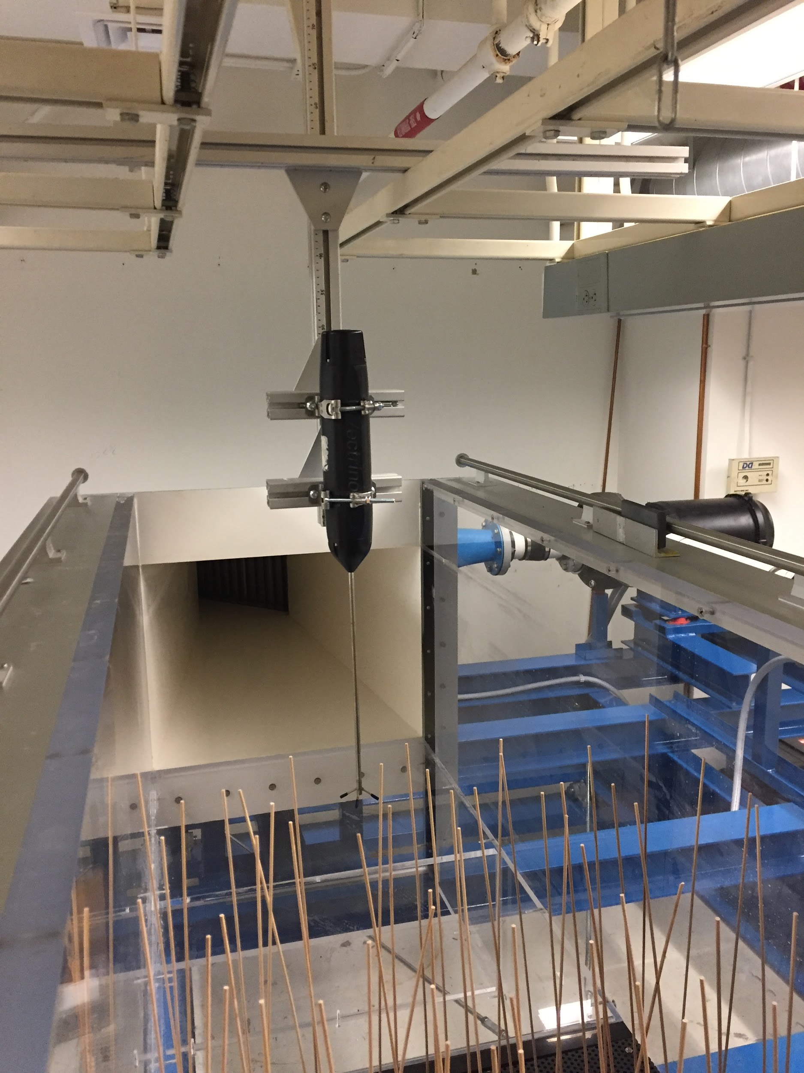

4.1.3 Peristaltic Pump Setup

1. We have been collecting water samples at depths of 5, 14, and 27 cm above the bed surface using peristaltic pumps. Samples at these depths are collected at two locations: at the upstream and downstream ends of the test section, centered between the two sidewalls. Thus, samples are collected at six unique locations.
2. Use zipties to attach hoses to a ~¼” diameter rod at the required heights, as shown in image below.
3. Attach each hose to the peristaltic pump using the pump “head” device. Make sure the pump heads are adjusted for the appropriate size of tubing. Note that the fit is very snug.
4. Attach the three upstream hoses to one pump and the three downstream hoses to the other pump. See images below for the 8020 apparatus used to position the rod on the upstream end, and for how to clamp the rod to the overhead cart on the downstream end.
5. Once hoses are in place and connected to pump, (and flume is filled) connect a fully-charged battery to each pump. Calibrate the flow rate of each tube to 50mL/min. The numbered knob on the pump adjusts the rate of pumping; make a mark a the calibration point in case it gets moved. Verify the flow rate of each tube before every flume run.
6. Tips for collecting pump samples:
   1. Helps to have one person collecting upstream samples and another collecting the downstream samples.
   2. Label and organize all sample containers before the start of the experiment.

4.1.4 Flume Setup

Note: flume should be filled before sediment traps and dowels are added. If dowels are installed and then flume filled, air bubbles tend to attach to the dowels and this may inhibit their ability to directly intercept particles. Sediment traps must be installed after filling so that residual sediment entrained during the filling process does not settle in the traps.

1. To fill the flume, ensure the valve below the vegetation array is open.
2. Connect the hose to the water faucet and the valve.
3. Fill the flume to at least the depth that submerges the inlet to the pump at the downstream end and no greater than 45 cm. We’ve generally been using a depth of 40cm.
4. Close the valve below the test section.
5. After filling, use the handle end of the mop or other similar device to agitate and remove any air bubbles in the test section, especially the many bubbles trapped in the vegetation array, which may not be visible.
6. If not using sediment traps, cover sediment trap holes in the vegetation array with sediment trap covers.
7. Place sealed plastic syringe tubes in the holes drilled through the flume vegetation array for sediment traps. Ensure that the cut side is facing upstream to prevent boundary layer effects from reducing settling into the traps.

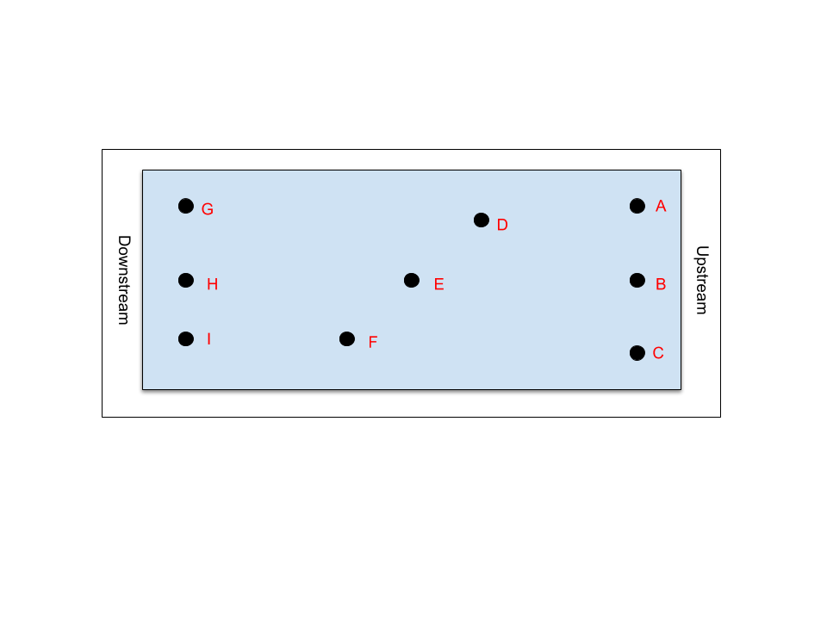

* 1. Each plastic syringe should be labeled by letter and placed in matching positions as indicated in the above diagram of the vegetation array (not to scale)

Positions of Sediment Traps currently in use in the 3/16” perforated sheet

Sediment Trap A: 15cm downstream from upstream edge of perforated sheet, 9cm from inner wall of flume

Sediment Trap B: 15cm downstream, 0 (middle between the two side walls)

Sediment Trap C: 15cm downstream, 11cm from outer wall of flume

Sediment Trap D: 74.5cm downstream, 14cm from inner wall of flume

Sediment Trap E: 93cm downstream, 0

Sediment Trap F: 115cm downstream, 16cm from outer wall of flume

Sediment Trap G: 175cm downstream, 10cm from inner wall of flume

Sediment Trap H: 175cm downstream, 0

Sediment Trap I: 175cm downstream, 11cm from outer wall of flume

1. Dowel greasing and installation procedure. (developed for ⅛” dowels):
   1. Use the greasing device, which is a 50mL falcon tube with the tip cut off and electrical tape applied over it, to apply a smooth layer of grease to the dowels. Each dowel should be passed through the device 2-4 times (depending on quantity of grease present in the device) in alternating directions. Use a gloved hand to even the coating of grease as necessary.
   2. Stick a small ball of wall putty with a hex nut at the base to the top of each dowel as a counterweight
   3. Place dowel with counterweight in flume. The dowels do not need to be placed in an exact pattern; a roughly uniform configuration will be sufficient especially at high densities.
   4. See section “Artificial Vegetation” for more details, as well as [external document](https://docs.google.com/document/d/1Kz7r6apvE45iflfMu09BJ_RONY3LuPipBL1tknP4r9k/edit?usp=sharing)
   5. One 5.3oz tube of chemplex 710 silicone grease is enough to coat ~200 dowels if applied liberally, or ~400 if applied conservatively.

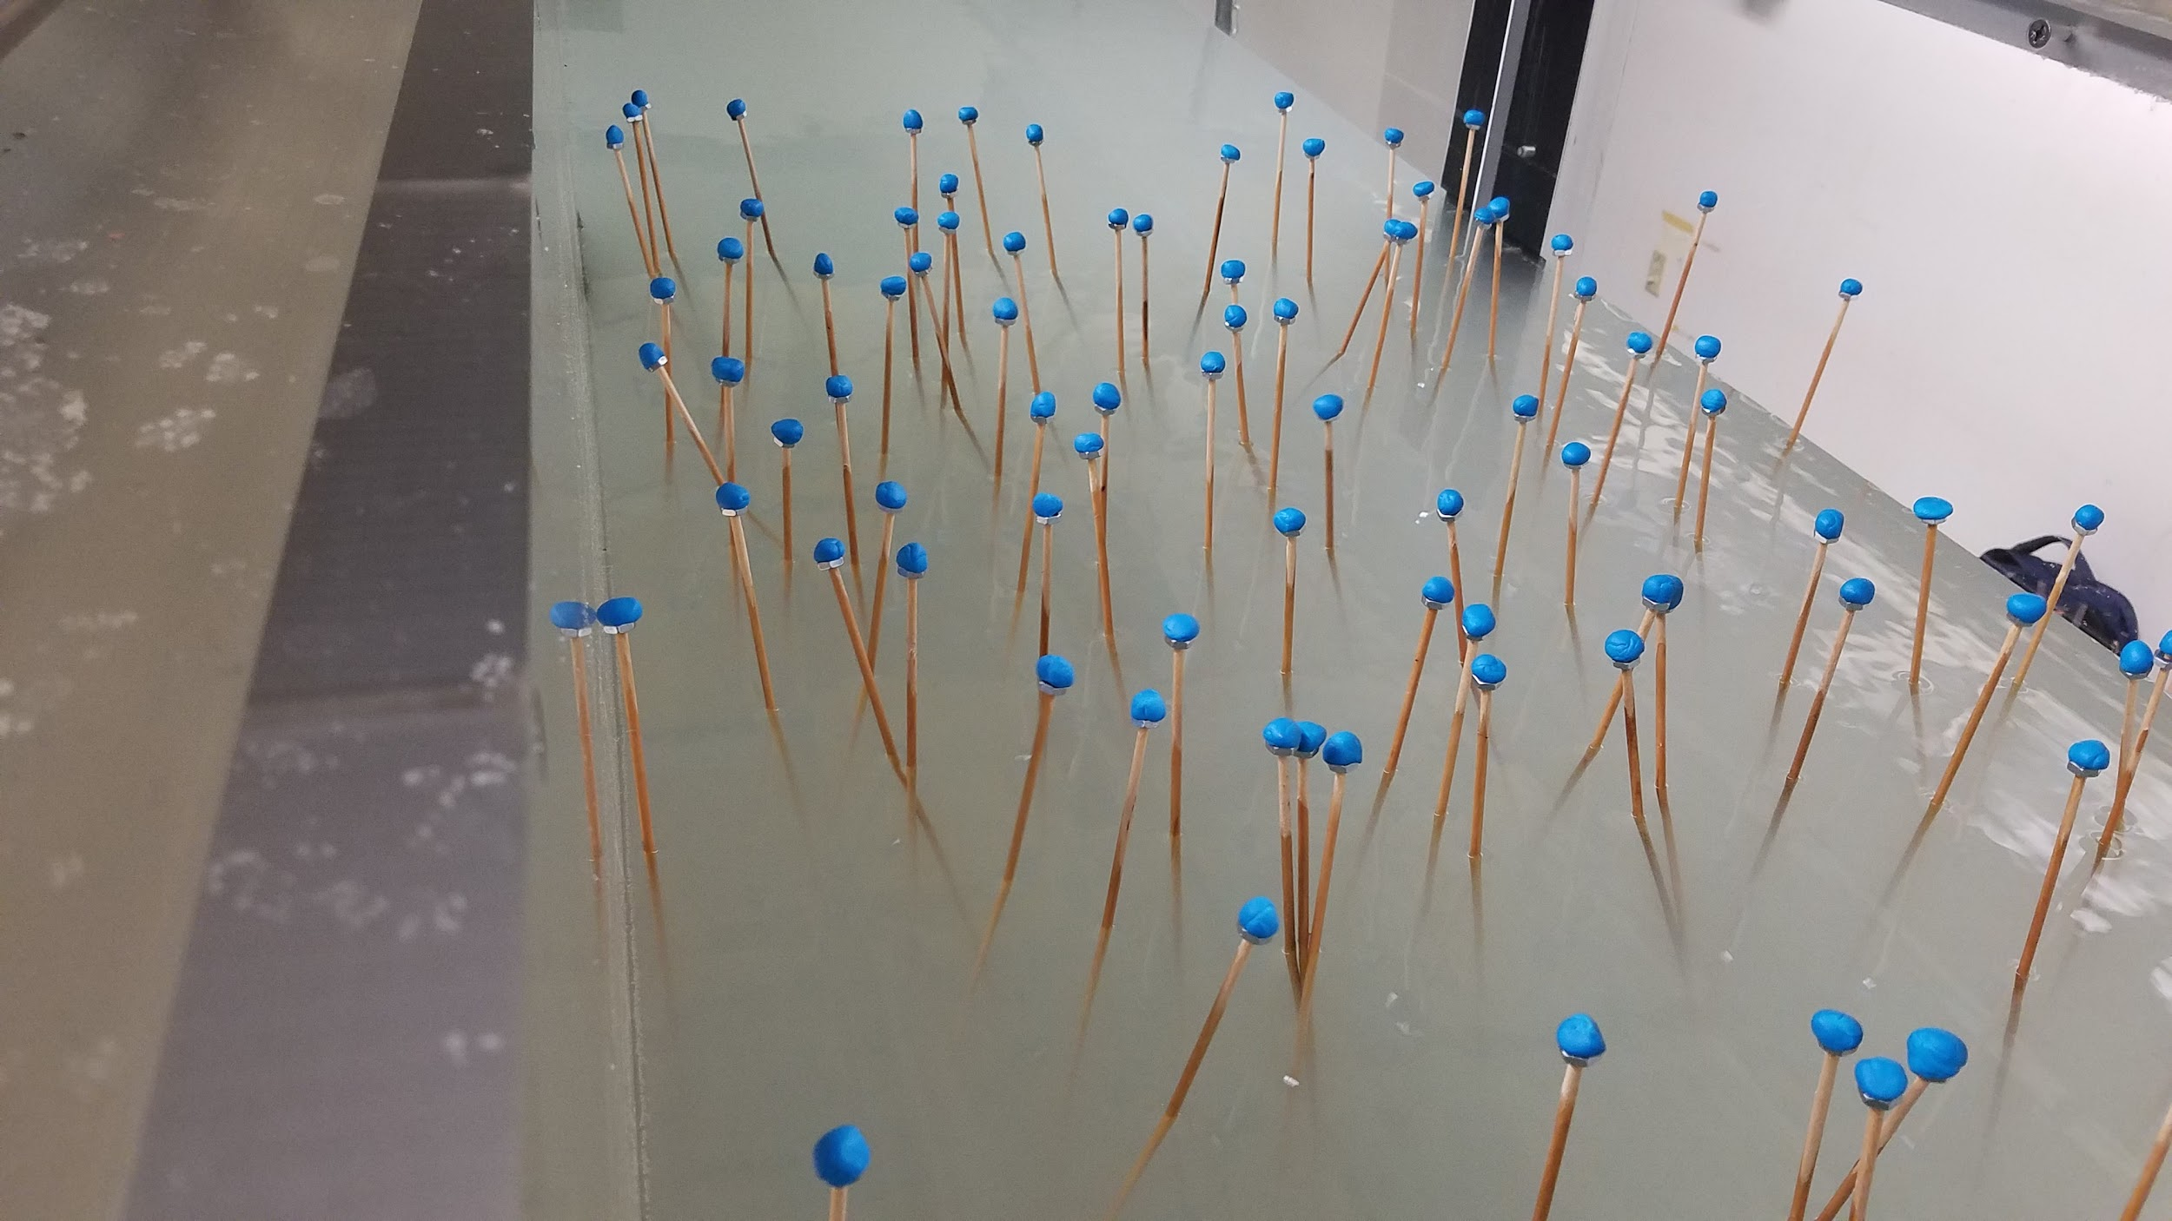

4.1.5 LISST Operation

1. Calibrate the time in the toolbar (Set Instrument Clock) in the LISST software
2. Set and apply experimental parameters
   1. Fixed sample rate: 1 sample/second
   2. Each measurement is an average of 10 samples
   3. Set start and end collection parameters, usually by time
   4. Save summary to .lop file for future reference
3. Accept the parameters once they have been set as desired
4. In the following dialogues, check the button to open the terminal window to track sampling progress during the data collection

4.1.6 Vectrino Operation

1. Connect to the instrument in the Vectrino software
   1. As with the LISST, you may need to test a few different serial ports to find the correct one
2. Set experimental parameters according to section 4.1.2
3. Ensure the “Save” icon is activated so that the Vectrino software actually writes the data
4. Select the “Play” button to begin data collection
   1. you will want to synchronize this with the data collection for the LISST; since the LISST may be programmed to begin collection at a specific time, simply set the Vectrino to collect for an equivalent amount of time and begin Vectrino collection once the time (on the computer) reaches the LISST start time

4.1.7 Experiment Initialization

1. Collect one pump sample from each location before turning on the flume.
2. Turn on the flume once the data collection has begun
3. Adjust the frequency settings on the control panel with the “up” and “down” buttons
   1. The frequency controls the flume discharge rate; we have used 30 Hz as a good benchmark frequency
   2. The frequency should not exceed much more than 30 Hz, otherwise cavitation to the pump will occur (sounds like rattling, crackling or popping), which causes damage to the pump.
   3. The flume will maintain a constant discharge at a given frequency (pump speed), so the velocity through the test section may be increased by decreasing water depth (but do not decrease the water depth below the level of the pump inlet)
4. Press “Run” to begin flow once a sufficient baseline (~2-3 minutes) has been collected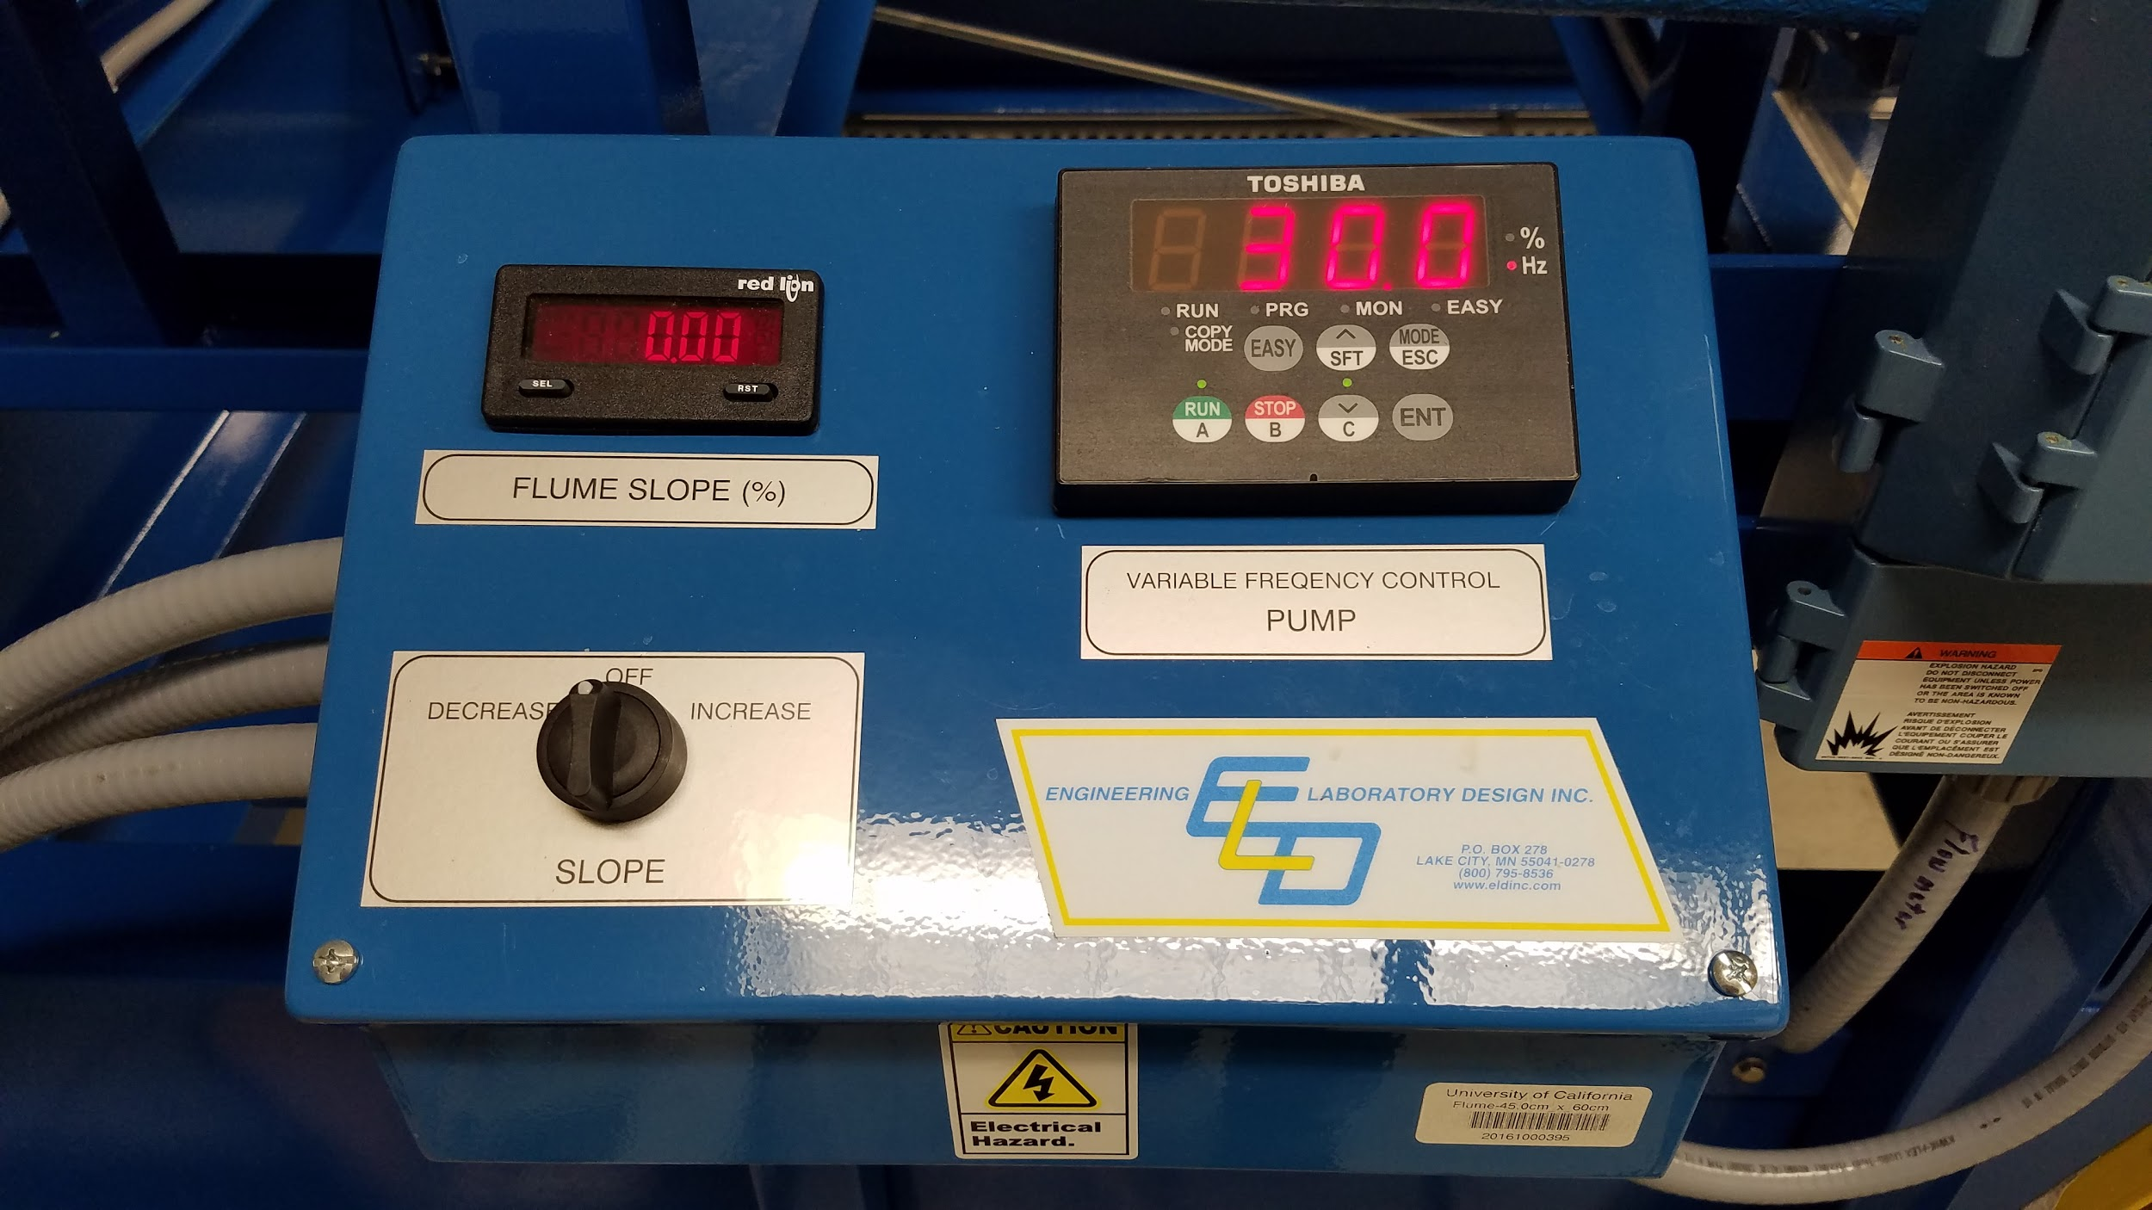
5. Collect another pump sample from each location after the flume has been running for 5 minutes, but before addition of sediment.

4.2 Post-Experimental Procedure

4.2.1 Flume Cleanup

1. Press “Stop” on the flume control panel to stop the flow in the flume
2. Shut off the flume power supply
3. Extract the plastic syringe sediment traps from vegetation array as necessary
   1. Insert the plunger into the top of the syringe and pull them out together to avoid disturbing the captured sediment (see image below)

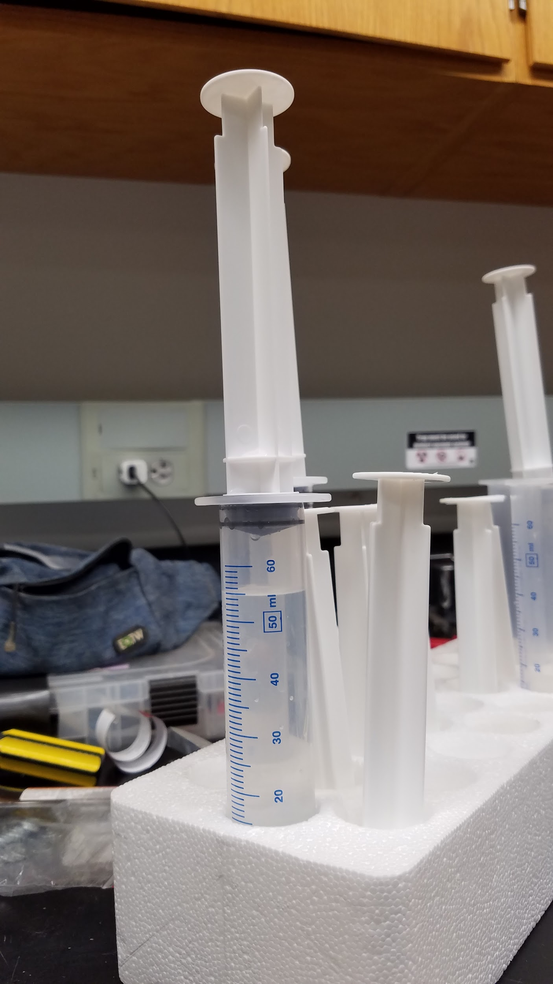

1. If a different experimental setup is required (e.g. using different sediment or cleaning the flume), drain the flume by routing the hose to the drain culvert located near the upstream end of the flume and opening the valve under the vegetation array
   1. flume drainage typically takes ~4 to 5 hours for 45 cm water depth
   2. Once drained, remove the honeycomb at the top of the open section and clean.
   3. Use the hose to spray out the enclosed sections behind the honeycomb and at the downstream end of the test section.
   4. Remove the vegetation array if necessary and clean. To remove vegetation array, screw eyebolts into the holes with hex nuts glued on the underside, attach rope/straps to eyebolts and lift up with crane. It is probably not necessary to disassemble the vegetation array for a normal cleaning.
   5. Always fill flume before dowels are placed to ensure that bubbles do not adhere to the dowels. After the flume is filled, agitate the vegetation array with the handle end of a broom or mop to remove trapped air bubbles on the underside.

4.2.2 Offloading LISST Data

1. Select “Offload Data” in the LISST software toolbar
   1. Note: The LISST stores the data on the instrument, so it is easiest to offload the data while the LISST-battery-computer setup is already in place
2. Navigate to the correct data file and follow the dialogues to save the file
3. Process the raw data file in the LISST software (File > Open Raw Data File)
   1. The result of the processing will yield several files; The .asc file contains the fully processed data
4. For processing the LISST data, use the R script located [here](https://drive.google.com/open?id=1NPuj671npwYm_1wM2a70gtLXynx1VHwX) (must be signed into a UC Berkeley account to view)
   1. For particle capture rate calculation, use the R script located [here](https://drive.google.com/open?id=1KYNx4tYwXoiERsDFJY4OYlr4dO6ZmZv9)
   2. Both scripts are extensively annotated; the main workflow is simply to replace the file path in the script with the file path to the data

4.2.3 Offloading Vectrino Data

1. Export the Vectrino data to Matlab (Data > Export Matlab)
2. Navigate to the correct .ntk file
   1. The .mat file will be saved to the same directory
3. For instructions and software related to further analysis of vectrino data in MATLAB, see <https://gitlab.com/ckeating/vectrino-data-analysis/>

4.2.4 LISST Cleanup

1. Remove all connecting cables for the LISST, battery, and computer
2. Remove the battery and two plastic stands from the overhead cart
3. Untie the rope from the overhead beams and carefully pull the LISST out of the flume
4. Rinse the portion of the LISST that had been submerged using clean water
   1. The LISST sensor should not have any residue
5. Return all LISST components to storage

4.2.5 Vectrino Cleanup

1. Disconnect the Vectrino from the computer
2. Disconnect the AC/DC transformer from the power outlet
3. Move the Vectrino out of the water and rinse the probe with clean tapwater.

4.3 Sample Processing

1. If analyzing the mass concentration and fluorescence of the pump samples (if tracer dye was part of the experiment), aliquot ~10mL from each sample container into a 15mL scintillation vial to be analyzed for fluorescence. Invert / agitate the sample to ensure that it is well mixed before subsampling.

4.3.1 Filtering

1. On the day before filtering the peristaltic pump samples, prefilter the glass microfiber filters by filtering ~100mL of DI water through them. The filters lose a small amount of mass during this step. Dry the filters overnight in the oven at 40C. The following day, record the initial dry mass of the filters using the analytical balance. Weigh the filters directly on the balance as opposed to in a tared weigh boat; we have observed additional error resulting from weighing the filters in weigh boats.
2. Filter the pump samples. Rinse the sample containers with DI water (to entrain any residual sediment) and filter that additional water through as well.
3. Dry the filters overnight at 40C and record their dried mass the following day.
4. Sediment traps should be filtered using the sample procedure. Give the sediment traps a thorough rinse with DI water to dislodge any sediment that may be stuck at the very bottom.
5. If samples are filtering very slowly (longer than 3-5 minutes per sample), consider filtering half the sample onto one filter and half onto another to dramatically reduce total filtering time.
6. [Example spreadsheet format](https://docs.google.com/spreadsheets/d/1_V4tcwvWRQOZSJCkzGPVfZoaz5Ro9Crnd1bn8nHgq2E/edit?usp=sharing)

**Flume Parameters:**

Constant Velocity: 30 Hz

Test section slope: 0

Water depth: 40 cm (maximum of 45 cm)

**Artificial Vegetation**:

Refer to “[Google Drive/Biogeomorphic Flume/Flume Vegetation Experiment Protocol](https://docs.google.com/document/d/1Kz7r6apvE45iflfMu09BJ_RONY3LuPipBL1tknP4r9k/edit?usp=sharing)” for further details on artificial vegetation densities.

Currently in use: ⅛” diameter dowels spaced at 1 per 100 holes. 183 dowels/m2, lowest density configuration.

**Data Analysis:**

Refer to workflow documents on Drive in the Biogeomorphic Flume Folder. The LISST data is processed in R; the Vectrino data is processed in MATLAB.

**Ideas for Further Improvement:**

Notes below are from conversation with Dino and Leonard:

1. Investigate issue where small particles have trouble attaching to dowels due to boundary layer surrounding dowel. Might this be a problem in our setup that is limiting direct capture?
2. Fix the expanding flow issue, where when the flow enters the test section with a porous perforated sheet, it is able to expand and slow due to the greater cross sectional area. Potential fixes are to use a film such as aluminum foil or plastic wrap to cover the perforated sheet, or to spread a layer of putty over the sheet. In either case after covering all holes, poke the dowels through only the ones that need to be used.
3. The sediment traps may be underrepresenting the amount of sediment settled across the test section because the bottom is sealed and for each particle that enters, some amount of water must be ejected. Consider a sediment trap with a porous membrane at the bottom that would catch sediment but allow water to flow through.
4. The sediment traps along the upstream and downstream edges of the test section may be influenced by flow that has memory from outside the test section. If so, this could also influence the amount of sediment that the traps are capturing.
5. As a complement (or alternative) to the peristaltic pump stations, research whether there is an instrument capable of measuring particle concentration over the entire water column. This could decrease the error and increase the resolution of samples compared to the peristaltic pump measurements.
6. Seal off bed of test section so water can no longer flow through the bed (tinfoil maybe) and create unusual flow patterns.